CLASSIFICATION MODELS
Introduction:
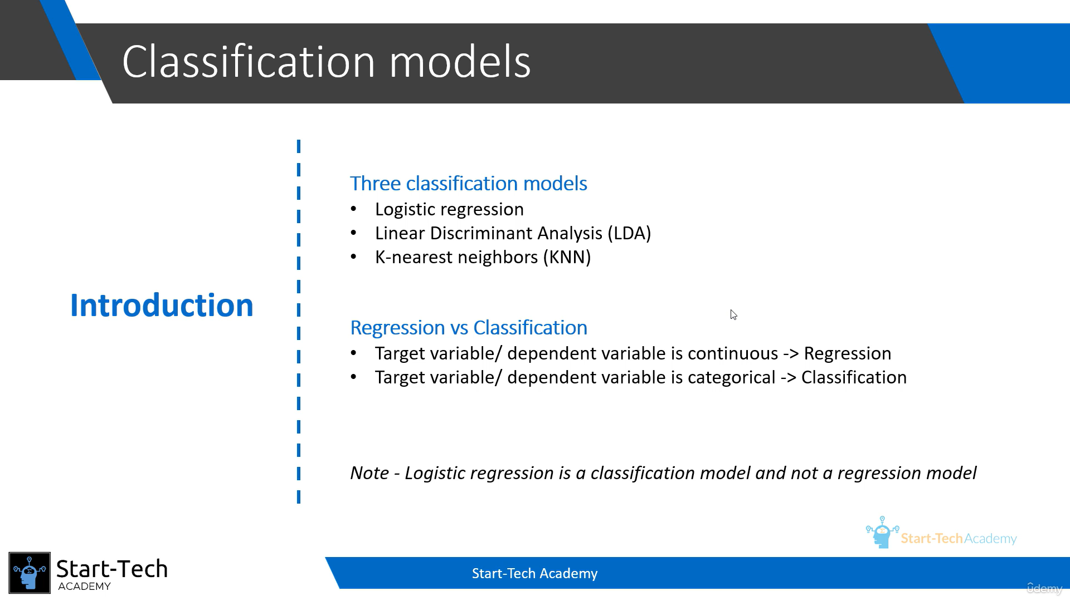
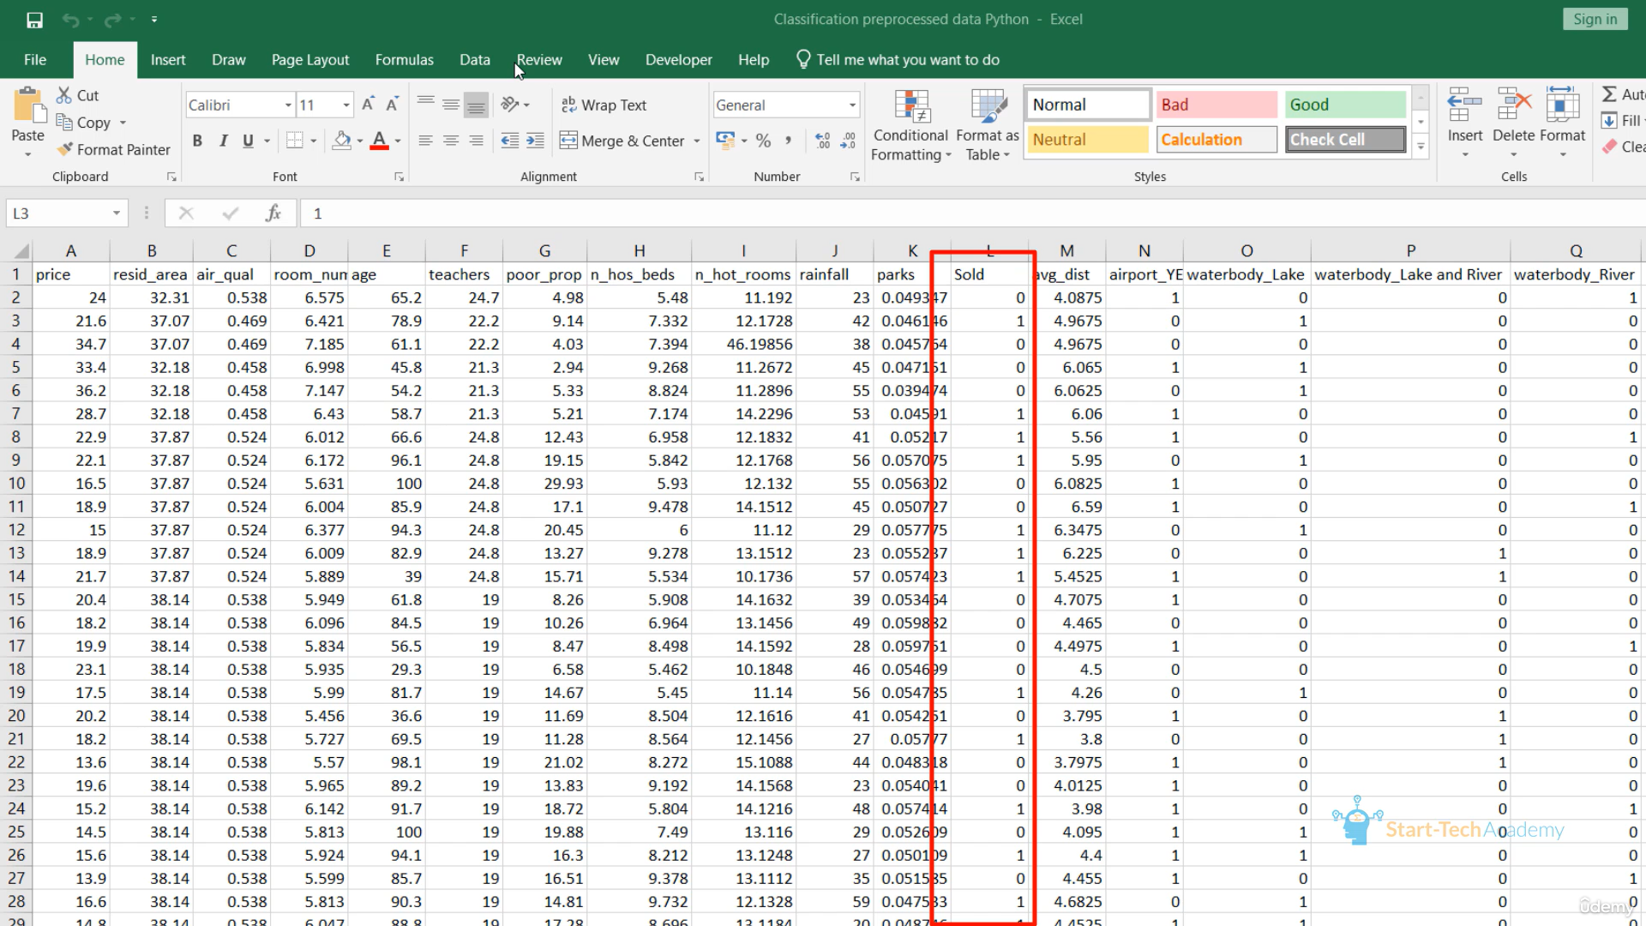
The above dataset is similar to the previous dataset, but it is already pre-processed and it has one extra variable ‘Sold’, which is the dependent variable here.
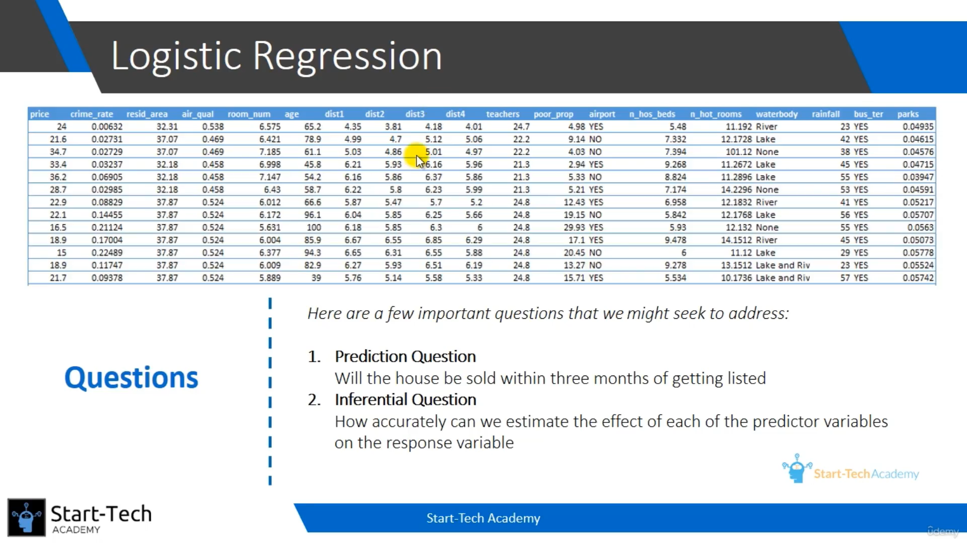
Why can’t we use Linear Regression:
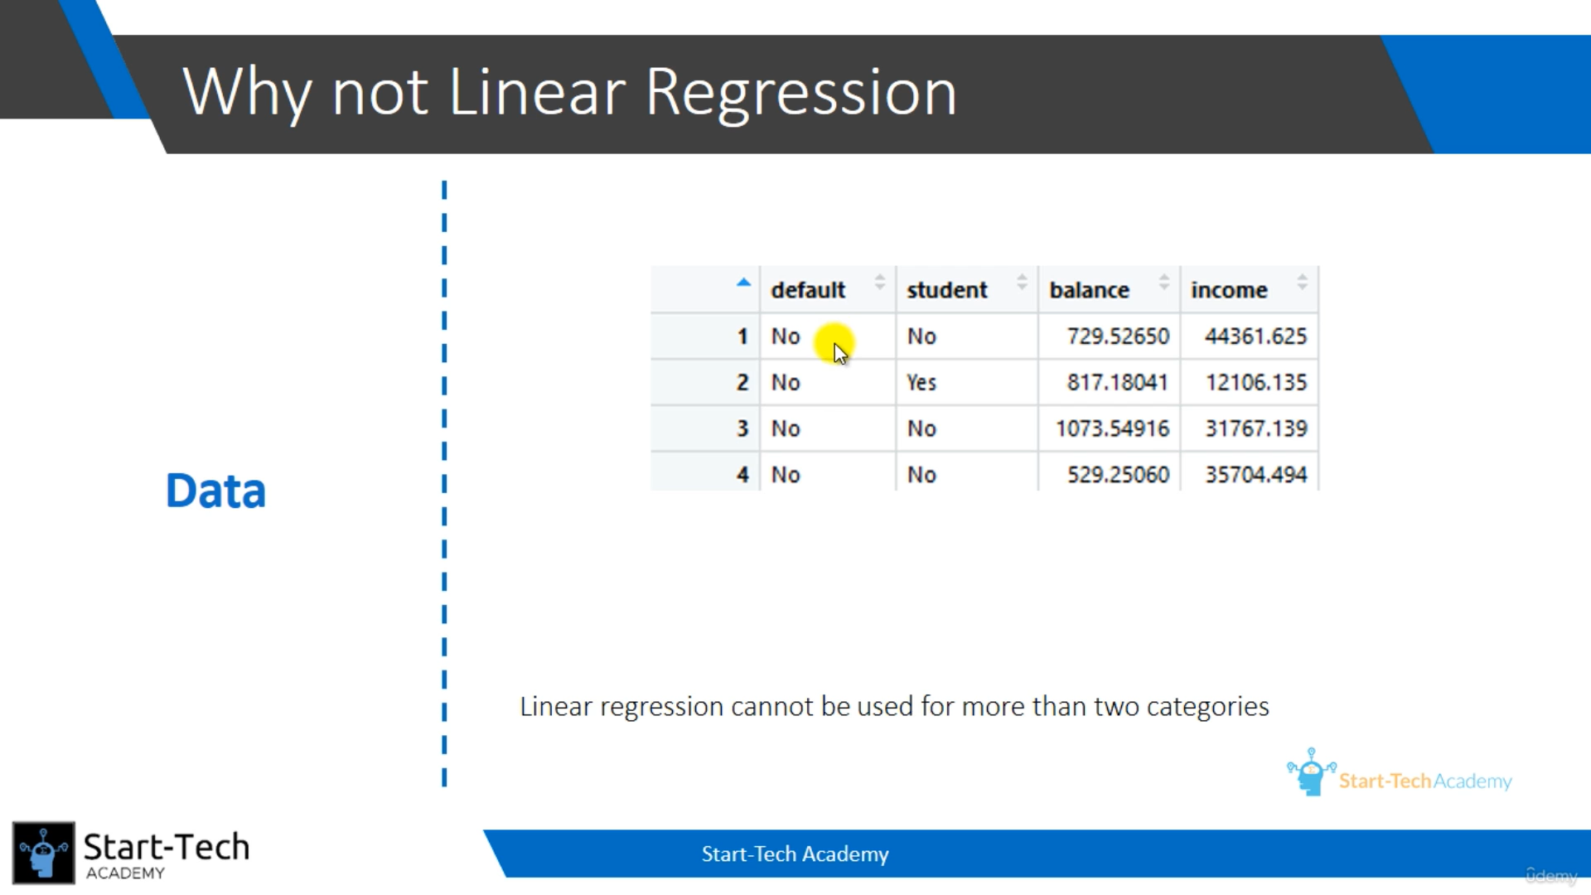
If we are having more than 2 categorical values in the target variable, we cannot able to get the linear regression to predict.
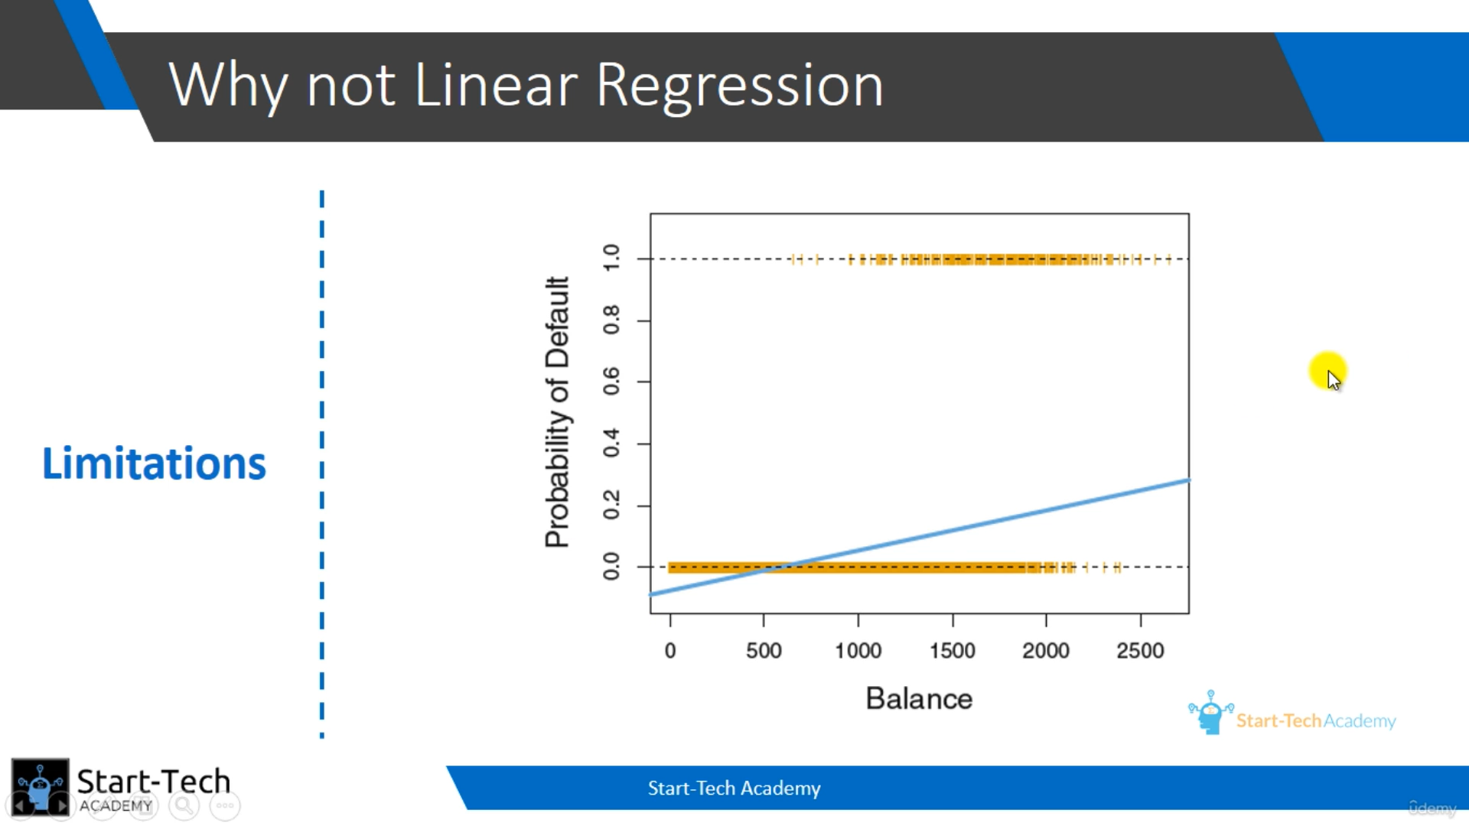
The Regression Line also takes from –infinity to +infinity, so we cannot possibly make the prediction of two or more than two categorical variables using Linear Model.
LOGESTIC REGRESSION:
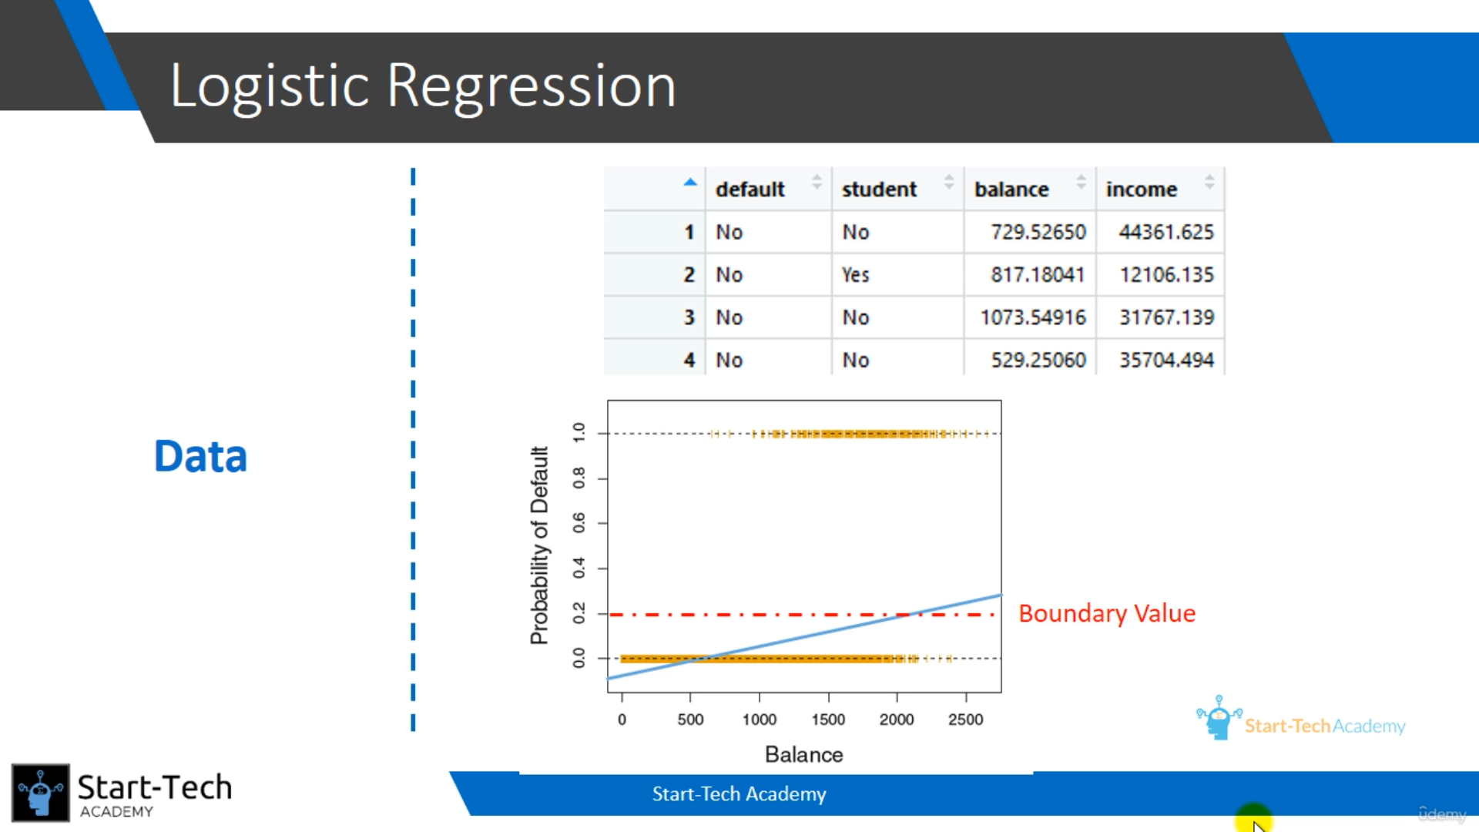
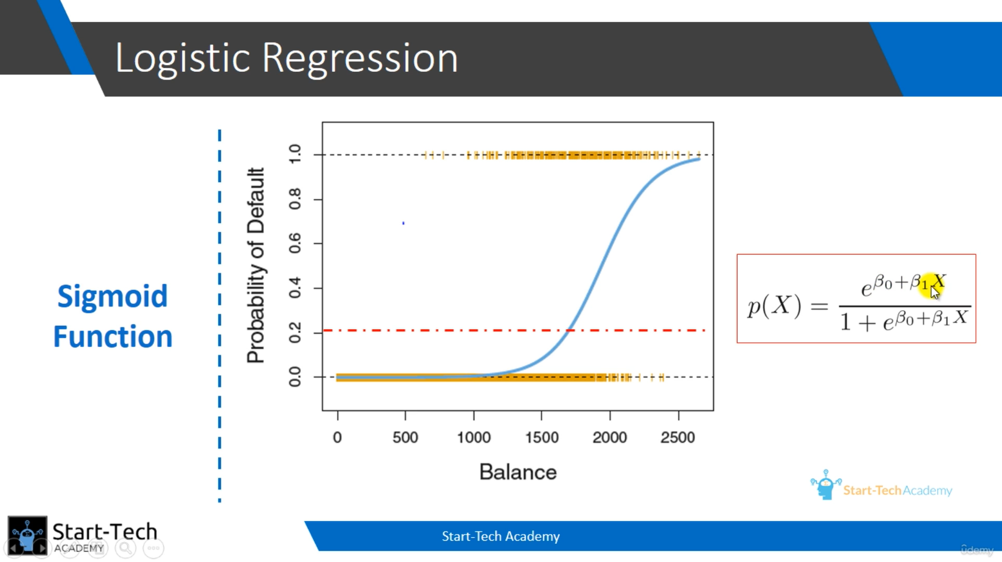
Here, the logistic curve tends to fit between 0 and 1, because of the sigmoid function.
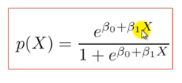
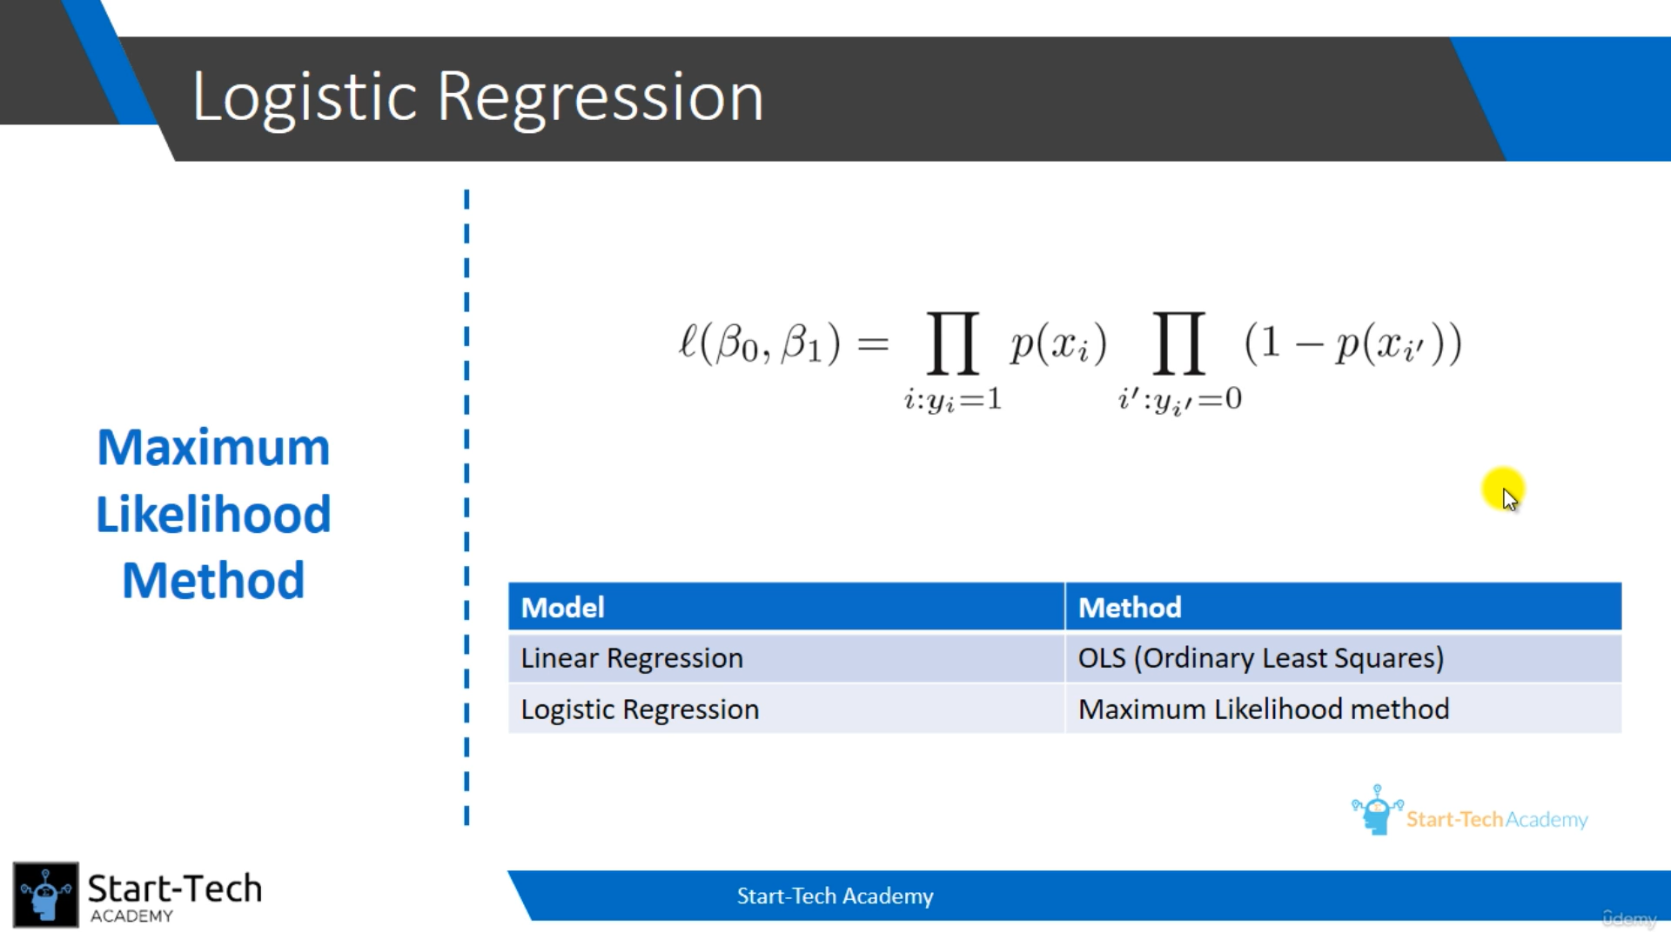
Here if a value is close (maximum near) to 1, then it is default. If a value is close (maximum near) to 0, then it is not default.
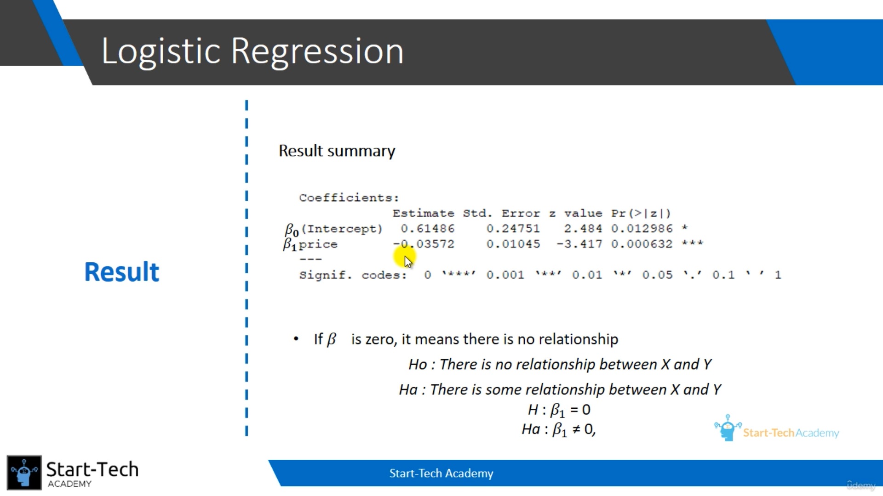z value is calculated by the division of beta1 by std. error and the p value is calculated by the z value.
We need to prove that there is some relationship between X and Y by negating the H0 (null hypothesis).
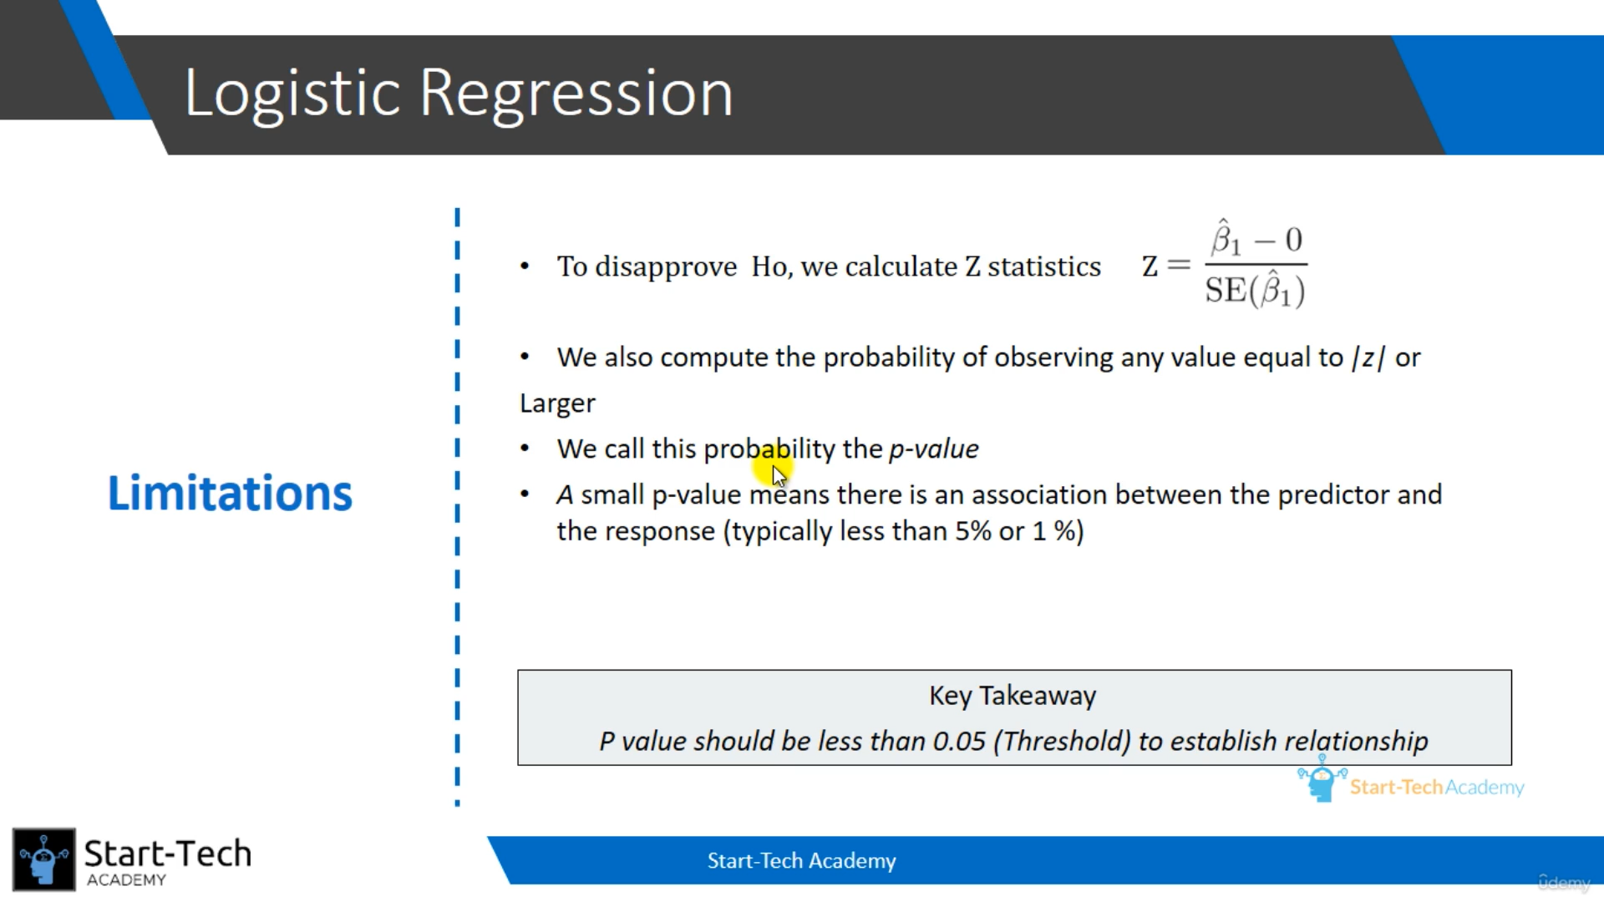
If the p-value is less than the threshold, we can negate the null hypothesis.
Logistic Regression with Multiple predictors:
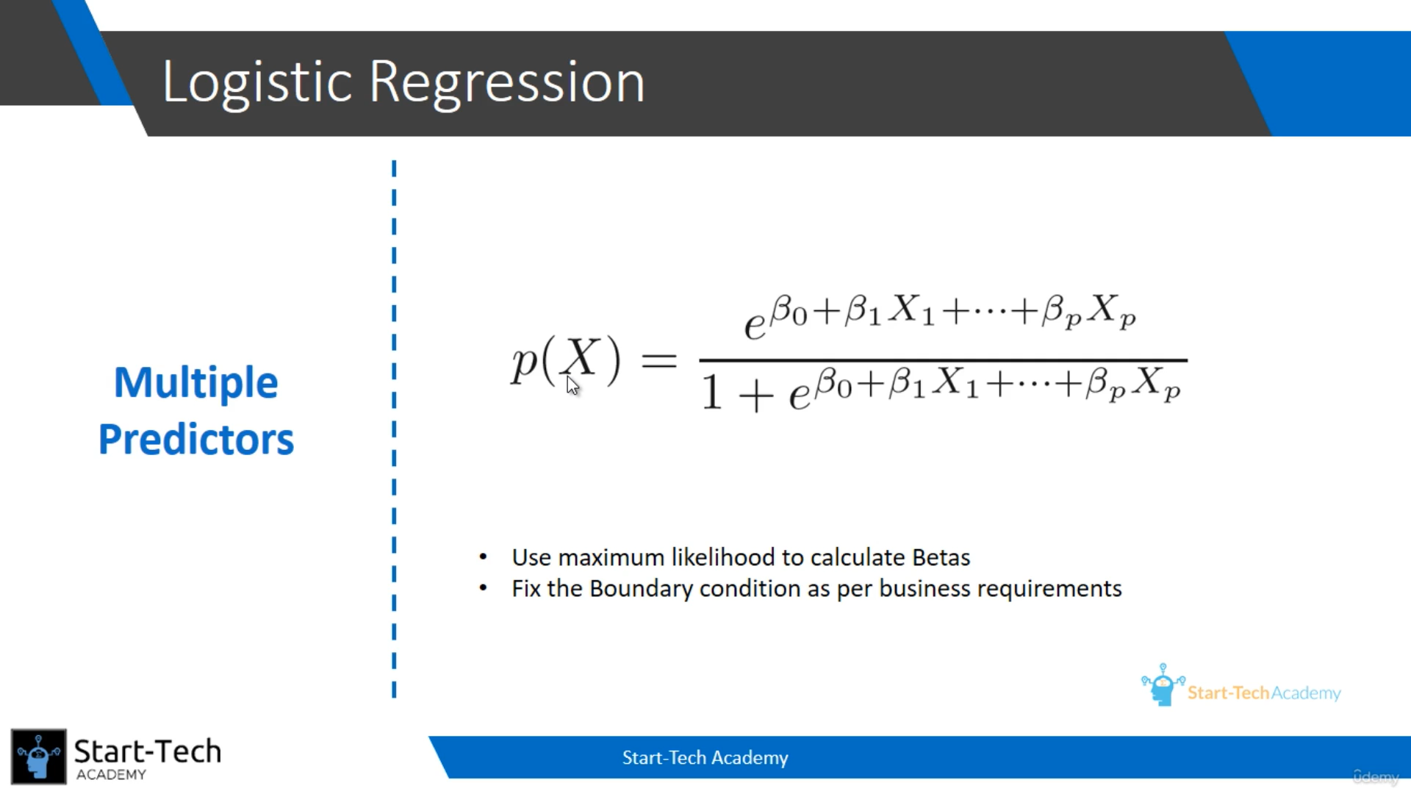
Boundary like determines which categories it will fall. Lets assume, if we fix boundary line as 0.5, the above 0.5 will fall into 1st category and below 0.5 will fall into 0th category.
Confusion Matrix:
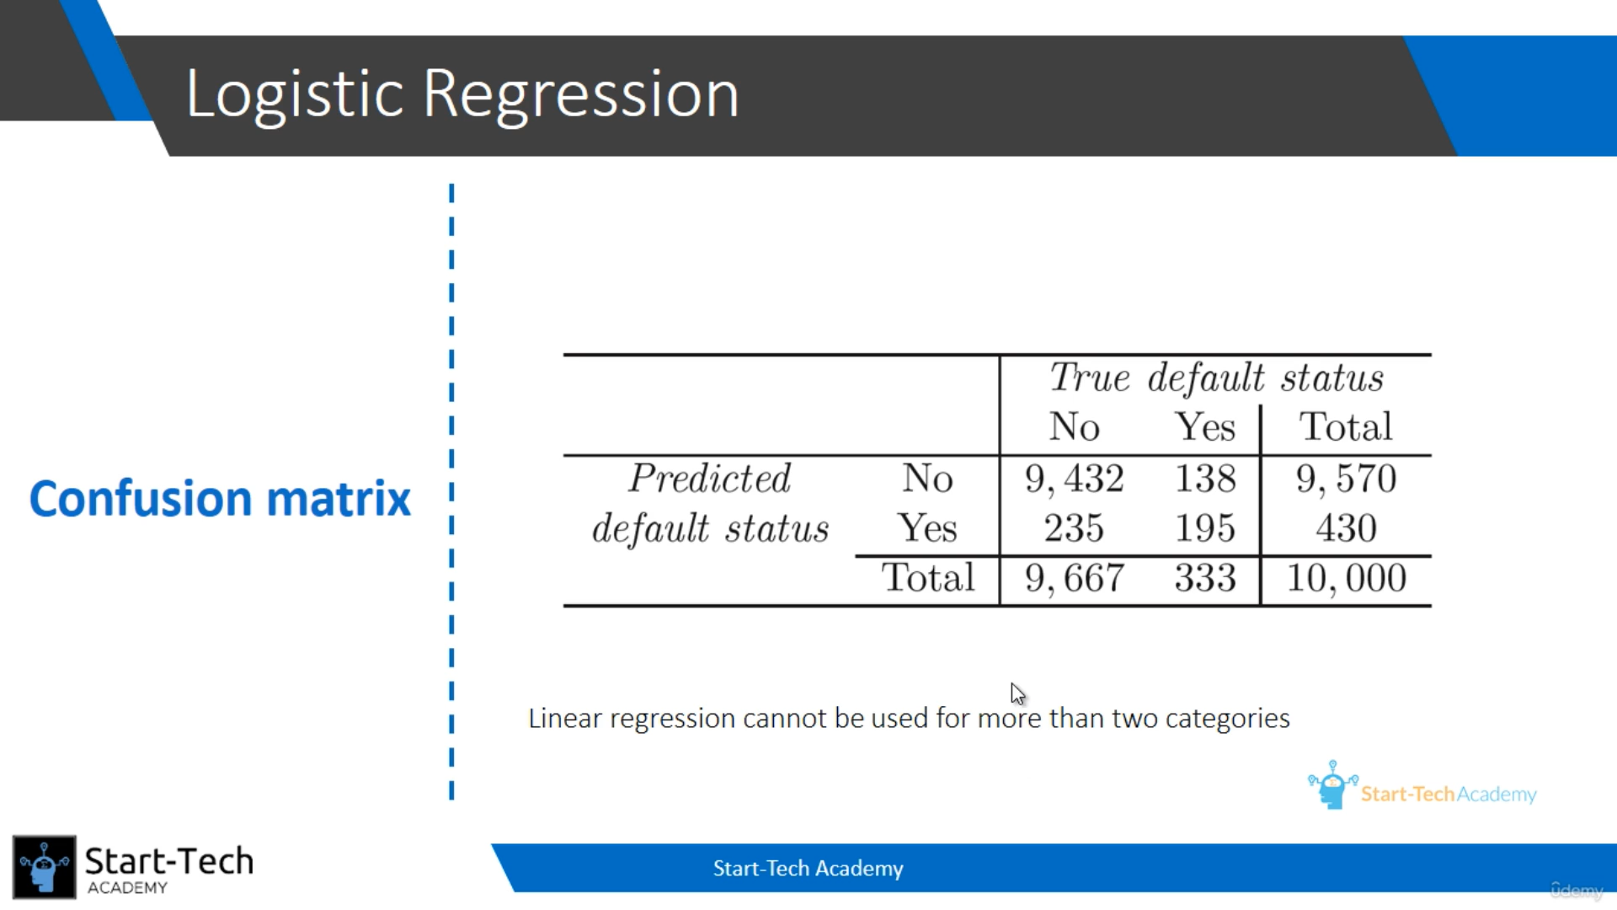
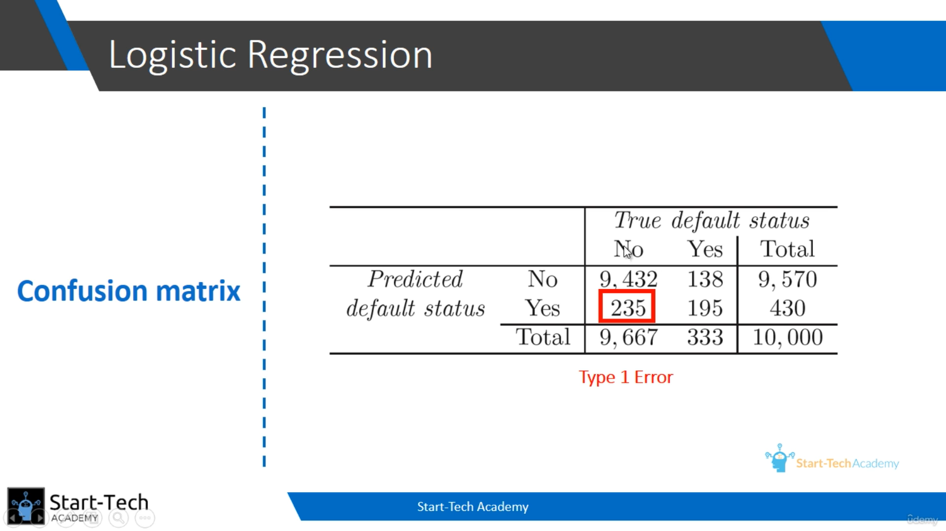
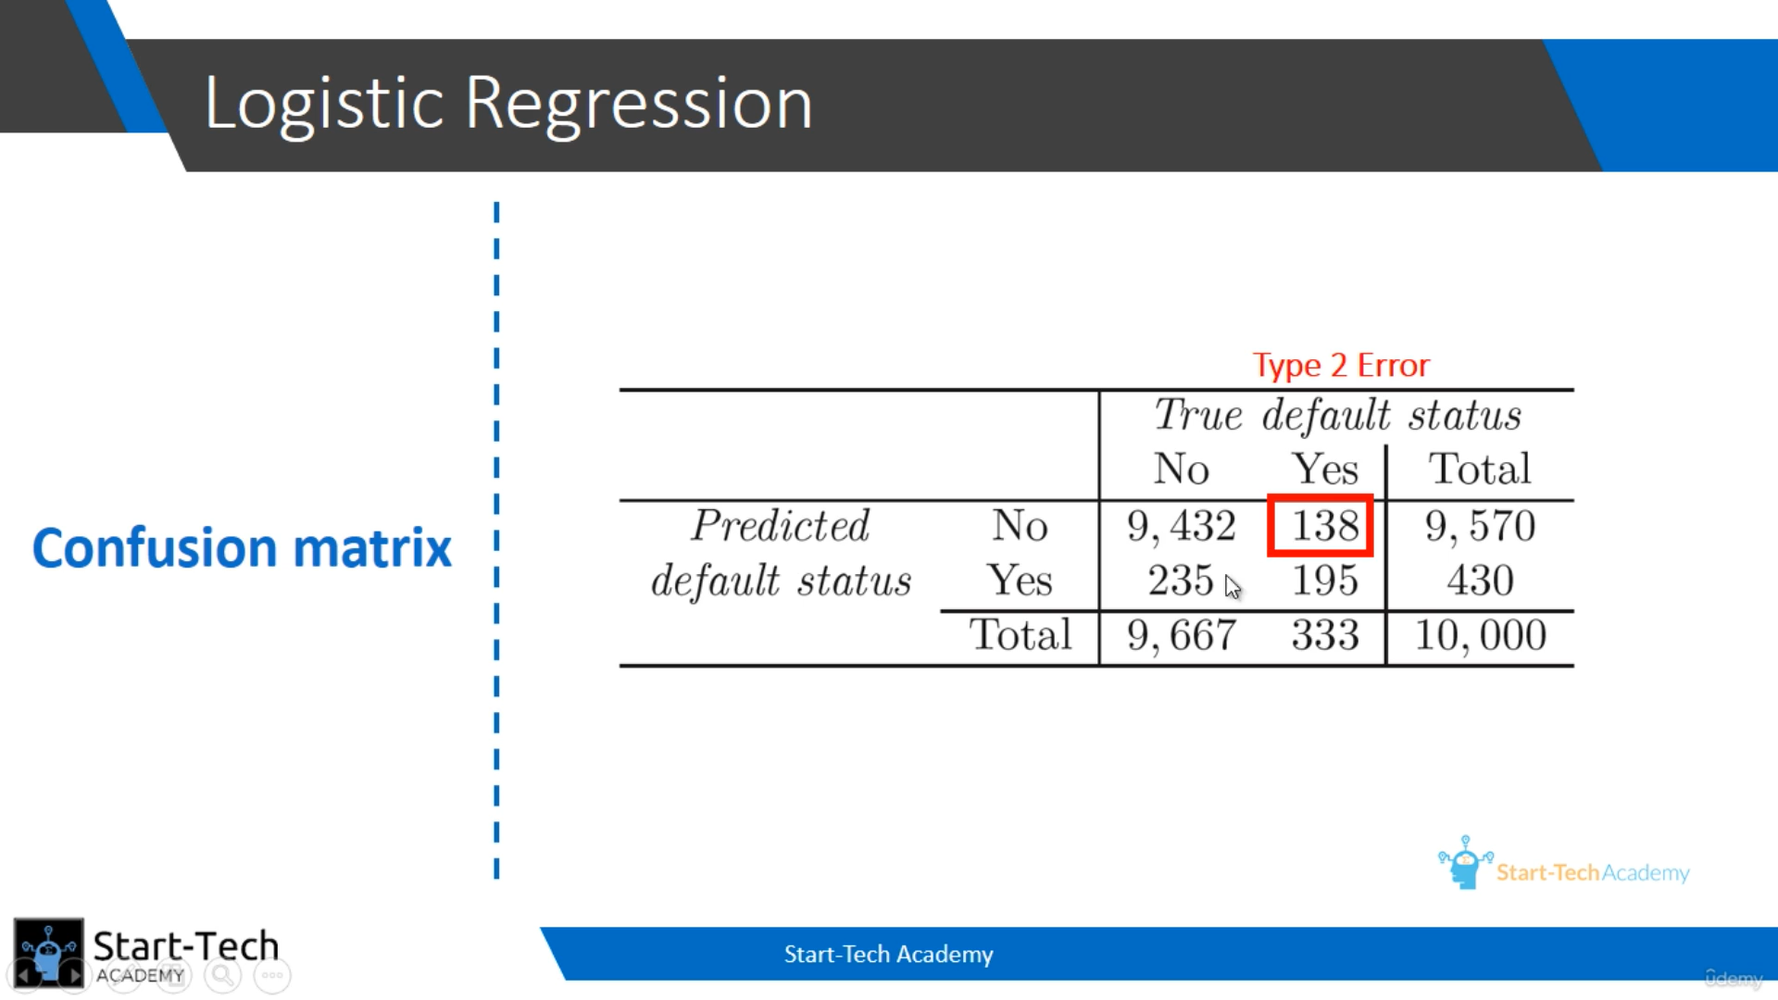
Type 1 Error (False positive) – When the value is ‘No’ but your model predicted ‘Yes’.
Type 2 Error (False negative) – When the value is ‘Yes’ but your model predicted ‘No’.
Reducing False positive is a good practice I guess.
